Air Tahiti Nui Challenge
Tahiti, December 18, 2021

Sommaire

The president’s welcome 2
The Clarisse’s welcome 3
The Matthieu ‘s welcome 3
The competition 4
Individual U14 Open 4
Individual Elite Open 5
Friendly Challenge by mixed teams 5
Training Camp before competition 6
Training Camp after compétition 6
Registrations 7
Accomodations 8
Transport 9
Health instructions 10
Contact & organization 12
Appendix – Competition rules 13

The president’s welcome

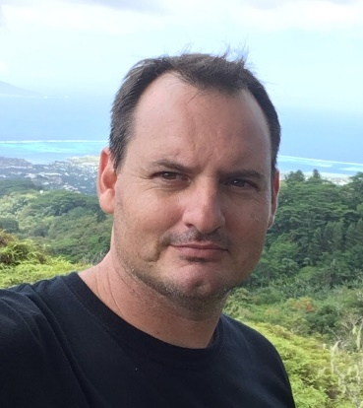
The Air Tahiti Nui challenge has become a traditional event in French Polynesia.This is an opportunity for us to promote judo and reaffirm our attachment to our partners. Because we are convinced of their social and educational usefulness, because they seem more relevant than ever, we wanted to make the values of judo a source of inspiration for this 2021 edition.
In a « Jita Yuwa Kyoei » spirit, we wanted to invite delegations from the countries served by the ATN company (Australia, Canada, Chile, United States, France, Japan, New Caledonia, New Zealand). This is an opportunity for our Federation to highlight our partner of always, but also to contribute humbly to the revival of tourism activity by making foreign delegations discover the sense of hospitality and Polynesian culture. We are committed to serving the general interest and building lasting ties of sharing and friendship with the invited delegations.
The mixed team tournament will also be organized in a "friendly" spirit. Indeed, each delegation will welcome at least one fighter from another delegation and will represent a local association of public utility to which we will pay a financial contribution, in particular through an appeal for donations and profits generated by the event.
It is also the spirit of fair play and the sense of respect that we want to convey during this event, by inviting two exceptional judokas. Indeed, Matthieu Bataille will referee the team gala on December 18, 2021 and will animate the pre-competition training camp from December 14 to 16, 2021. Triple world medalist, French representative at the Olympic Games in Athens as a fighter and then at the Tokyo Games as a referee, Matthieu embodies these values better than anyone.
From 20 to 23 December, the five-time World Champion, the individual and team Olympic Champion Clarisse Agbegnenou, will lead an international training camp. The flag bearer of the French delegation in Tokyo with whom we will celebrate the great success of the French Olympic team will share with Polynesian and foreign judokas her experience of very high level judo. It is an example for our youth, a synthesis of what generosity and the sense of effort are.
Thank you to ATN, Matthieu, Clarisse, all the volunteers and fighters for offering us this opportunity to gather around the values of judo.
Stéphane Gustin

2

The Clarisse’s welcome

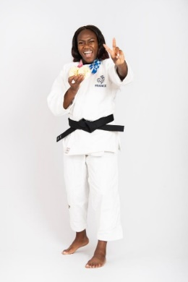
Friendship, sharing and fair play are the leitmotivs that drive me on a daily basis. So I am convinced that sport softens hearts and brings men and women together. In my opinion, it is of public utility, instruction, education and fraternity. I am therefore proud and honored to share these values with the Polynesian Judo Federation and to take part in the 2021 edition of the Air Tahiti Nui International Challenge.
It’s a great opportunity for me to live this moment with each of the participants and to make my modest contribution by sharing my experience.
Clarisse Agbégnénou

The Matthieu ‘s welcome

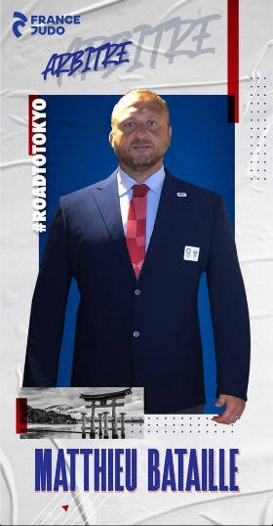
It is a real pleasure and honour for me to have accepted your invitation, and I thank you for that. I am delighted to participate in this event organized by the Polynesian Judo Federation. This moment of sharing will be for me the opportunity to exchange on our discipline at all levels, technical, physical, regulatory.
It will also be an opportunity to present my career as a high-level athlete and to put my experience as a referee to the benefit of this stay, with coaches, clubs, young judokas and not so young.
I already know that we will spend pleasant moments in this idyllic setting with children and adults who will be present in a spirit of kindness, conviviality and sport. I look forward to meeting you and exchanging with you. I know I'll learn just as much! It is a beautiful and rich experience that awaits us on your island.
Matthieu Bataille

3

The competition

Age categories | Women | Men
Individual U14 Open  Judokas born between 2008 & 2011 | -36kg / -40kg / -48kg / -52kg / -57kg / -63kg / +63kg | -36kg / -42kg / -46kg / -50kg / -55kg / -60kg / -66kg / +66kg
Individual Elite Open  Judokas born in 2007 & before | -57kg / -70kg / +70kg  (Open to U14 medalists born in 2008 & 2009) | -55kg / -60kg / -66kg / -73kg  -81kg / -90kg / +90kg
Friendly Challenge by mixed teams  Judokas born in 2007 & before | M-66kg / F-57kg / M-73kg / F-70kg / M-81kg / F+70kg / M+81kg

Individual U14 Open
(Selective for the french cup Minimes)
Program & organization of the fights
- Official weigh in 7h30 to 8h30
- Draw at 08h30
- Start of fighting at 09h30
- Competition formulas :
  - 2 fighters : Round trip match
  - Between 3 and 5 fighters : A competition pool in direct confrontations
  - Between 6 and 7 fighters : Competition pool in direct confrontations + Table without repechage
  - 8 fighters : Table with double repechage
  - More than 8 fighters : Table with full draft
- The tournament is refereed by young Polynesians, supervised by Mathieu Bataille, IJF World Referee who officiated at the Olympic Games Tokyo 2020. A Young Referee Cup is thus organized and will give rise to awards
- Forecast end : 12h30
Possible regulatory adaptations:
- Judokas born in 2011 can fight in the weight category below their category
- Judokas born in 2008 & 2009 are grouped in a half table, judokas born in 2010 & 2011 in another half table.
4

Individual Elite Open
(Account for polynesian ranking list)

- Draw the december 17 at 19h00
- Random control weighin at 13h00 (4 fighters by category) 5% weight tolerance allowed
- Start of fighting at 14h00
- Competition formulas :
  - 2 fighters : Round trip match
  - Between 3 and 5 fighters : A competition pool in direct confrontations
  - Between 6 and 7 fighters : Competition pool in direct confrontations + Table without repechage
  - 8 fighters : Table with double repechage
  - More than 8 fighters : Table with full draft
- The tournament is refereed by Mathieu Bataille, Tokyo 2020 Olympic referee and by the official Polynesian referees
- Forecast end : 17h30

Friendly Challenge by mixed teams
(gala evening)

- Number of teams : 4
- Composition of the teams :
  - 4 men (born in 2007& before) : -66kg / - 73kg / -81kg / +81kg
  - 3 women (born in 2009 & before) : -57kg / -70kg / +70kg
  - Possibility to mix teams (USA, CAN, FRA, PYF)
- Start of fighting at 18h30
- Competition formulas :
  - 2 semi-finals simultaneously
  - 1 small final
  - 1 Final
- Forecast end : 20h00
- The tournament is refereed by Mathieu Bataille, Tokyo 2020 Olympic referee
- Closing cocktail of the tournament : From 20h00
Each team will represent a local association recognized as being of public utility. Rather than an entrance fee, each spectator is invited to make a donation of the amount of his choice. With this prize pool, supplemented by any profits generated by the tournament, the FPJ will pay:
- 100.000XPF for the association represented by the 1st team
- 50.000XPF for the association represented by the 2nd team
- 30.000XPF for the association represented by the 3rd team
- 20.000XPF for the association represented by the 4th team

5

Training Camp before competition

The FPJ organizes a free course, open to all participants in the tournament and all Polynesian licensees born in 2011 & before.The course will take place from 14 to 16 December 2021 at the federal dojo of La Fautaua, on the basis of one training per day;

It will be hosted by Mathieu Bataille, triple bronze medalist at the World Championships (2007, 2008 and 2010) and IJF referee who officiated at the Tokyo Olympic Games

Training Camp after compétition

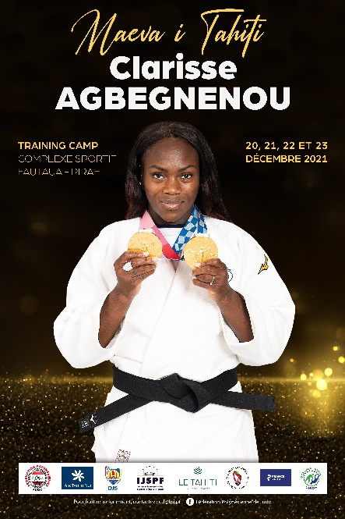
The FPJ organizes a free course open to all participants in the tournament and all Polynesian licensees born in 2011 & before.
The internship will take place from 20 to 23 December 2021 at the federal dojo of La Fautaua
It will be led by Clarisse Agbegnenou, 5-time World Champion, Individual and Team Olympic Champion and flag bearer of the French delegation at the Olympic Games Tokyo 2020.
In order to combine sports exchange and cultural exchange, the course will be organized at the rate of one judo session per day.
The FPJ will also offer a paid visit of Tahiti and/or Moorea to the delegations participating in the training camp.

6

Registrations

To be returned no later than October 31 at midnight on ctf@fpj.pf
DELEGATION (club, country) : ____________________________________________
Head of team : ____________________________________________
Mail : ____________________________________________
Name – First name | Function  (Coach, fighter, Official) | Date of birth | Weight category | Training Camp 14 to 16 | Training Camp 20 to 23

7

Accomodations

The accommodation of foreign delegations is fully covered, within the limit of 44 fighters, between December 13 and December 23, 2021. Priority is given to the 3 invited foreign delegations. To welcome the fighters, we have:
- 5 X 6 single beds
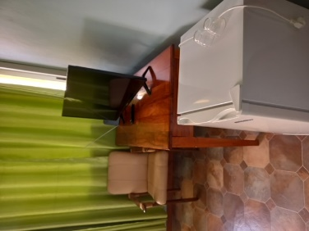
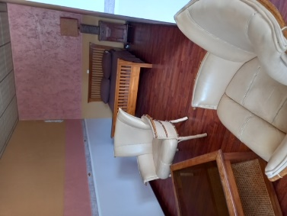
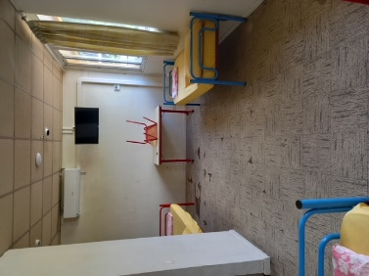
- 5 X 2 single beds
- 4 V.I.P rooms

The accommodation of the head of team (and his or her spouse) is taken care of by the organization in the hotel "Le Tahiti By Pearl"

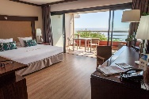
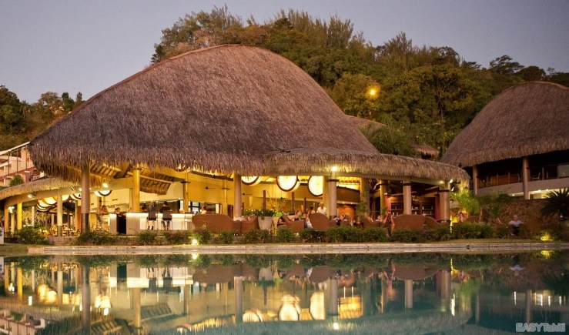
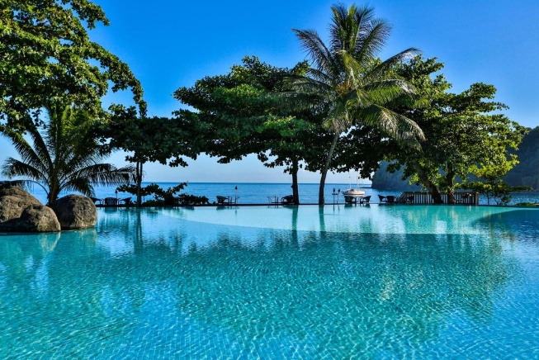

To be returned no later than October 31 at midnight on ctf@fpj.pf
DELEGATION (club, country) : _____________________________________________
 | Number of persons | Date of arrival | Departure date | Number of nights
Head of team

Men Fighters & Officials

Women Fighters & Officials

8

Transport

For the three partner delegations of the 2021 edition (CAN, USA, FRA), the FPJ:
- Supports the ATN flight ticket of the delegation manager (minimum 4 fighters)
- Centralizes the reservation of ATN tickets at the rates indicated below

Flight | XPF / Pers | € / Pers | US$ / Pers | CAD$ / Pers
Paris – Papeete | 150.000 | 1255 | 1460 | 1835
Los Angeles – Papeete | 100.000 | 840 | 975 | 1230

The delegations are responsible for booking and paying for the trip to Paris or Los Angeles, with the company concerned.

To benefit from the flight management of the delegation manager, the latter must :
- Return the document below, duly completed, for the entire delegation, before midnight on 31 October, on ctf@fpj.pf
- • Pay into the FPJ account a deposit of 50% before October 31 at midnight
- • Pay into the FPJ account, the balance before November 7 at midnight

DELEGATION (club, country) : _______________________________________
AIRPORT (Los Angeles ou Paris) : _______________________________________
DATE OUTBOUND FLIGHT: _______________________________________
RETURN FLIGHT DATE : _______________________________________

Name – First name | Date of birth | Passeport  Number | Date of issue | Expiry date | Remarks | Price  (Specify currency)
1. |  |  |  |  |  | 0
2.
3.
4.
5.
6.
7.
8.
9.
10.
11.
12.
13.
14.
15.
16.
17.
18.
19.
20.
Total to be paid to the FPJ
Deposit to be paid to the FPJ no later than October 30, 2021
Balance to be paid to the FPJ no later than November 7, 2021
9

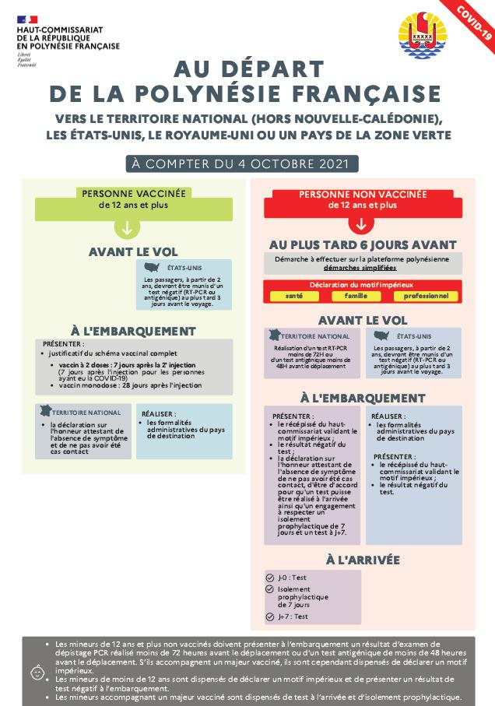
Health instructions
10

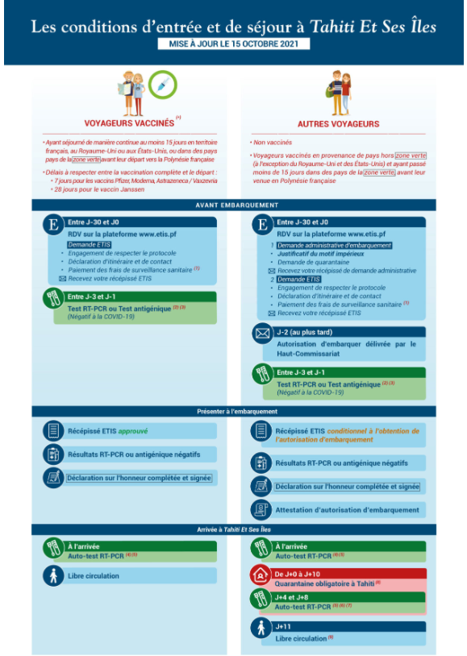

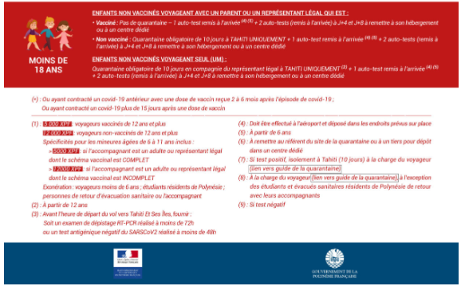

11

Contact & organization

Polynesian Judo Federation :

Dojo Fédéral de la Fautaua
BP52972
98716, Pirae, Tahiti, Polynésie Française

General information, registrations, reservations & transfers :
Franck BELLARD +689 87741855 ; ctf@fpj.pf
Stéphane GUSTIN ; +689 87 71 19 85 ; president@fpj.pf

Delegations that do not fall within the scope of the invitations mentioned above, or who wish to independently manage the organization of their travel and accommodation can contact our partners :
- Contact Air Tahiti Nui : leilani.leone@airtahitinui.pf
- Contact hôtel Tahiti By Pearl : reservations@pearlresortsoftahiti.com (Contact Franck BELLARD to get the promotional code)

12

Appendix – Competition rules
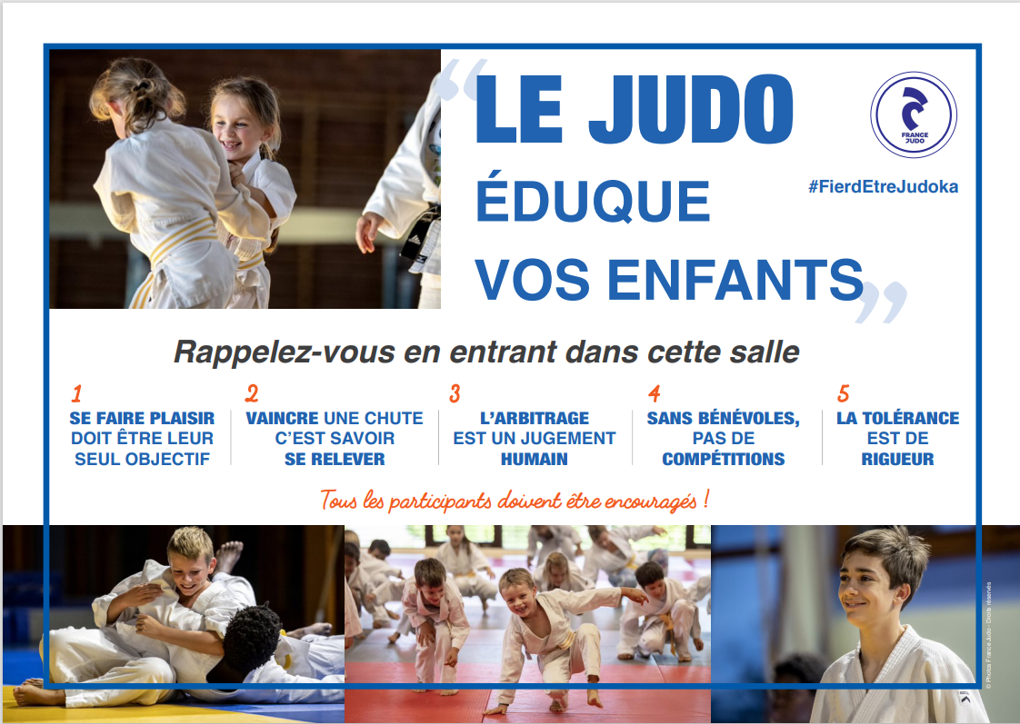
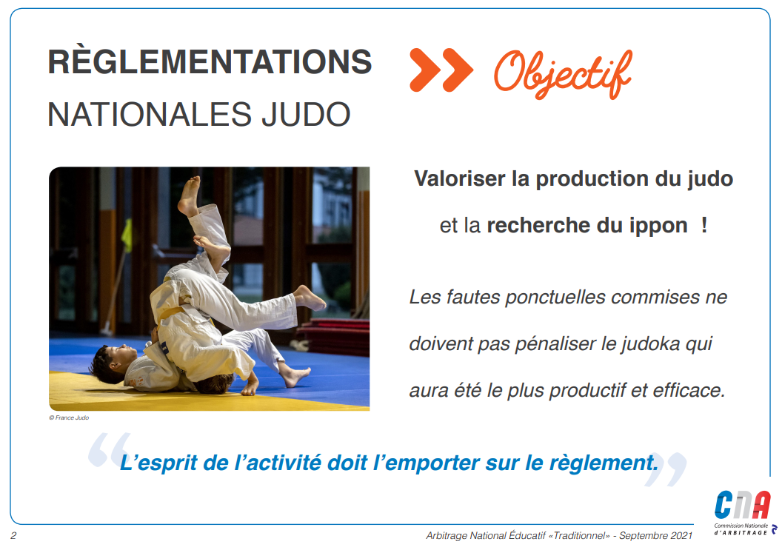
13
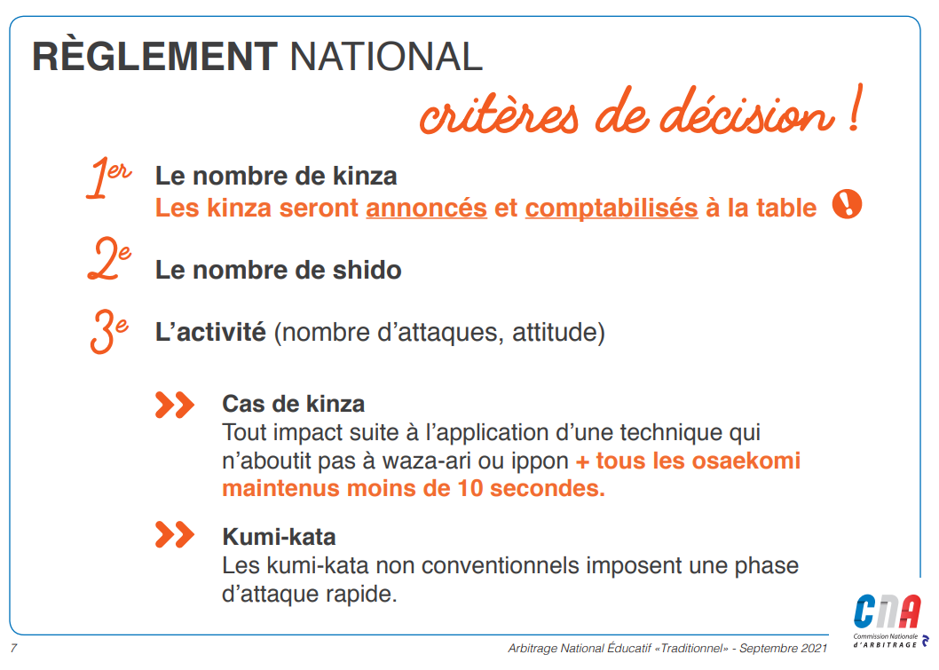
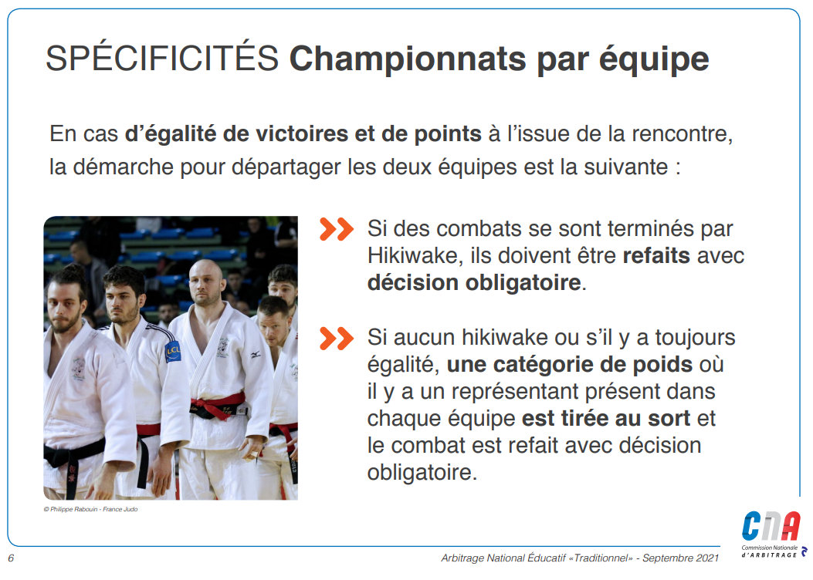
14

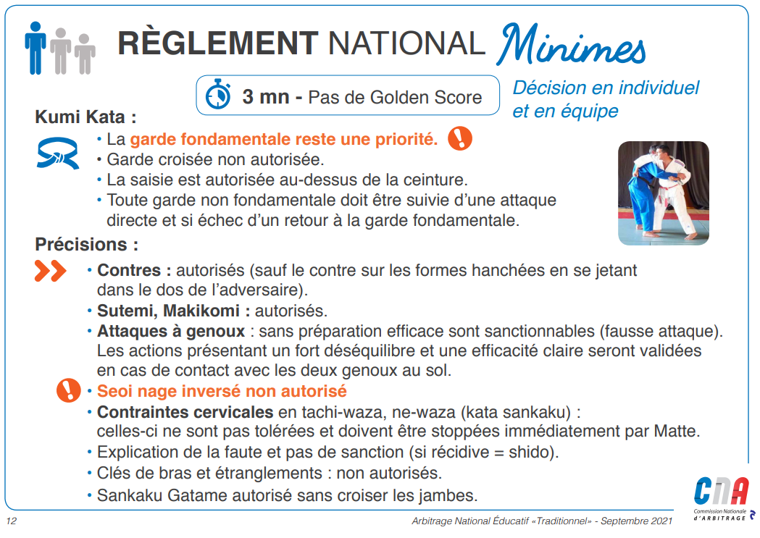
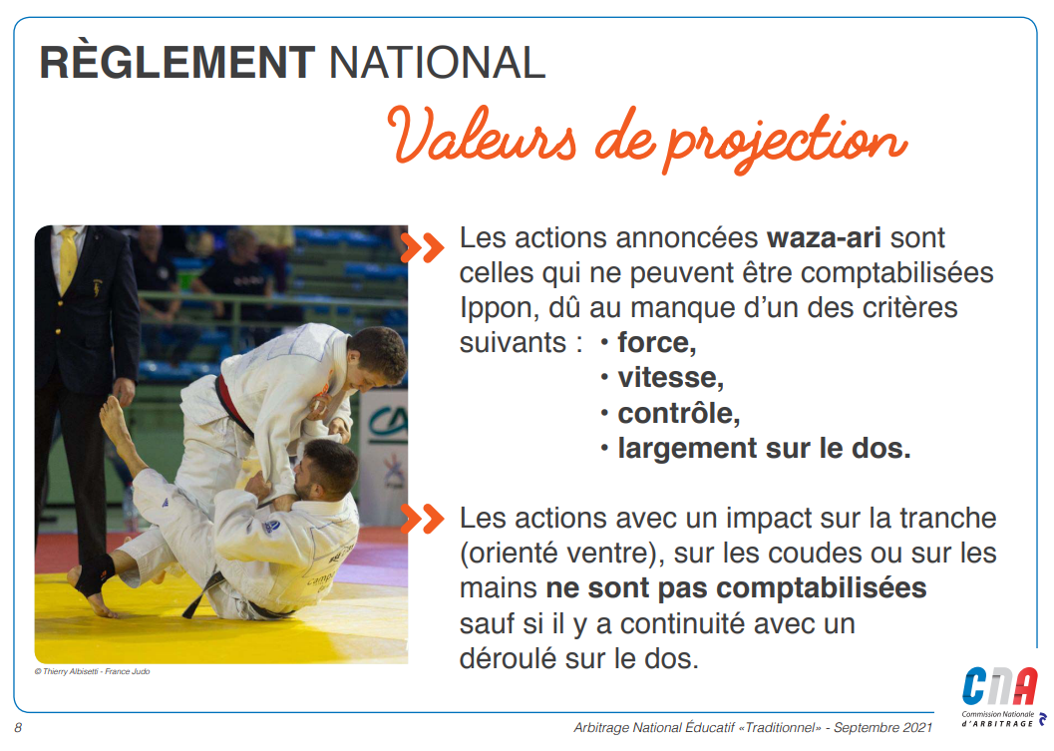
15
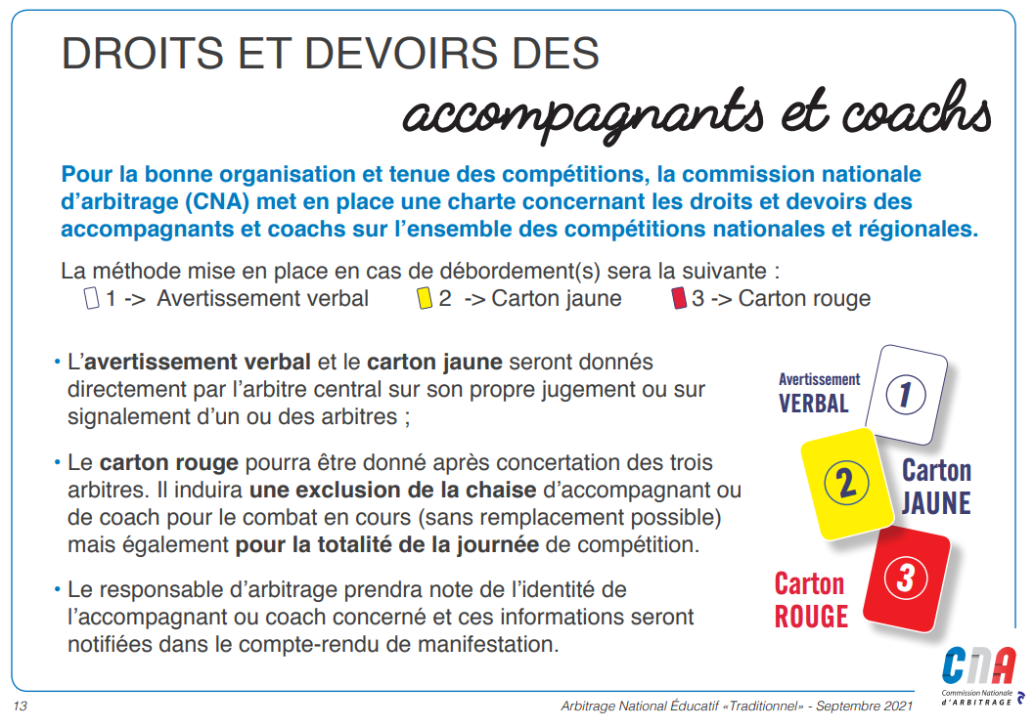
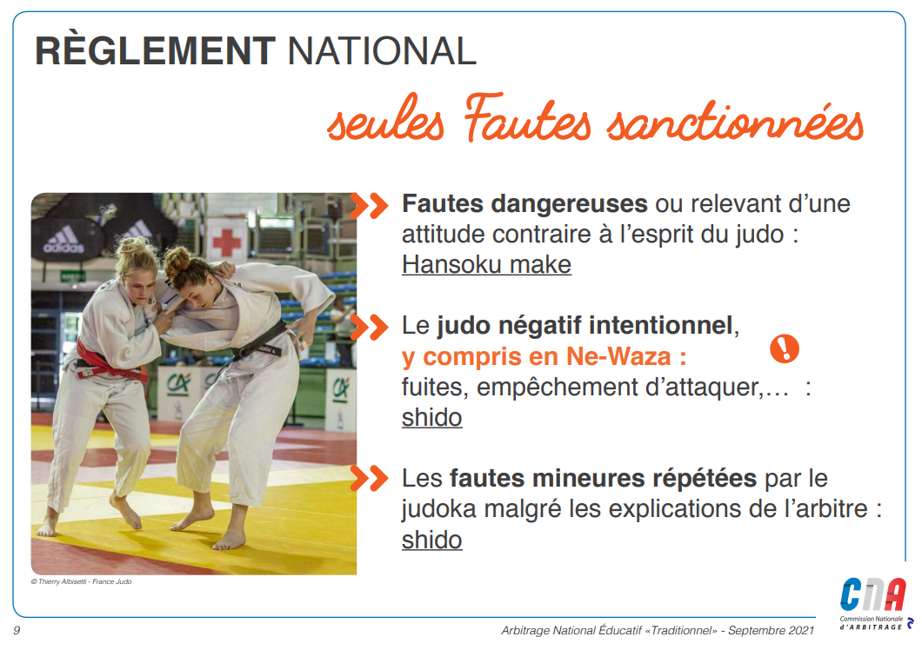

16
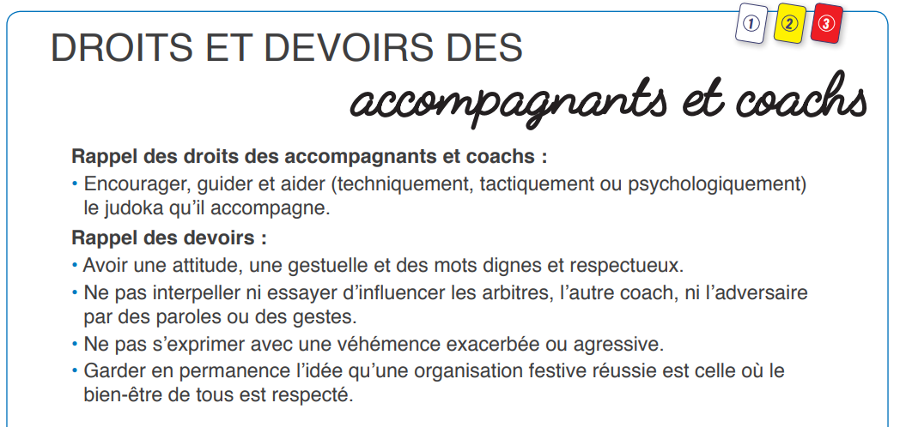
Dans le cadre de ce tournoi, les coachs sont autorisés à parler pendant l’action, dans le strict respect de leurs devoirs.

17

